PRACTICAL 4
Login Module - Test Execution Report
Automation-Oriented Functional & Non-Functional Testing
Application Under Test: https://practicetestautomation.com/practice-test-login/
Tester | Tester
Execution Date | 03-Aug-2026
Module | Login Module
SDLC Model | Agile Model
Total Test Cases | 35
Pass Rate | 85.71%

1. Introduction
This report documents the design and execution of an automation-oriented test suite for the Login module of the Practice Test Automation demo application. The objective was to validate functional correctness alongside non-functional characteristics - UI presentation, navigation, boundary and input-validation handling, performance, cross-browser and responsive behaviour, security posture, and error handling - so that the resulting test cases can be lifted directly into a Selenium/WebDriver automation framework with minimal rework.
Each test case below is written the way it would be structured for automation: a fixed set of locators, deterministic test data, an explicit expected assertion, and a recorded actual result from execution against the live application.

2. Test Environment
Application / Software | https://practicetestautomation.com/practice-test-login/
Module Name | Login Module
Test Type | Manual execution with automation-oriented design (Selenium WebDriver-style locators, assertions, and data-driven notes) for future CI integration
Browsers Covered | Google Chrome (latest stable), Mozilla Firefox (latest stable), Microsoft Edge (Chromium-based, latest stable)
Operating System | Windows 11
Viewport / Devices | Desktop 1920x1080, Tablet 768x1024 (iPad), Mobile 375x667 (iPhone SE) via browser device emulation
Valid Test Credentials | Username: student | Password: Password123
Test Data Source | Sample credentials published on the application page, supplemented with boundary, injection, and whitespace payloads authored for this suite

3. Scope and Test Approach
The following ten testing dimensions were covered across 35 test cases:
- Functional Testing - core login behaviour for valid and invalid credential combinations
- UI Testing - presence, state, and visual correctness of page elements
- Navigation Testing - redirects, logout flow, and browser history behaviour
- Boundary Testing - minimum and excessive-length field inputs
- Input Validation - injection payloads, special characters, and whitespace handling
- Performance Observation - page load and response-time characteristics
- Compatibility Testing - Chrome, Firefox, and Edge
- Responsive Testing - mobile, tablet, and desktop viewports
- Security Observation - password masking and information-disclosure checks
- Error Handling - repeated-attempt behaviour and dynamic error-message updates

4. Execution Summary
Metric | Value
Total Test Cases Designed | 35
Total Test Cases Executed | 35
Passed | 30
Failed | 5
Blocked / Not Executed | 0
Pass Percentage | 85.71%
All 35 test cases were executed in a single pass on 03-Aug-2026. No test cases were blocked; 5 test cases failed against their expected result and are documented as observations in Section 7.

5. Module-wise / Category-wise Results
Category | Total | Passed | Failed | Pass %
Functional Testing | 6 | 6 | 0 | 100.0%
UI Testing | 4 | 3 | 1 | 75.0%
Navigation Testing | 4 | 2 | 2 | 50.0%
Boundary Testing | 3 | 3 | 0 | 100.0%
Input Validation | 5 | 5 | 0 | 100.0%
Performance Observation | 3 | 3 | 0 | 100.0%
Compatibility Testing | 3 | 3 | 0 | 100.0%
Responsive Testing | 3 | 3 | 0 | 100.0%
Security Observation | 2 | 1 | 1 | 50.0%
Error Handling | 2 | 1 | 1 | 50.0%

6. Pass / Fail Statistics by Priority
Priority | Total | Passed | Failed
High | 6 | 6 | 0
Medium | 17 | 13 | 4
Low | 12 | 11 | 1
All High-priority (core functional) test cases passed without exception. The five failures identified are concentrated in UX-guard, navigation/session, and security-observation categories, none of which block the primary login/logout workflow but which are relevant findings for a production-grade authentication system.

7. Detailed Test Execution Log
Each test case is presented with its steps, data, expected and actual results, execution status, and a screenshot placeholder for evidence capture during formal automation runs.

Functional Testing
TC_AUTO_001 | Verify successful login with valid username and password | Pass
Steps: 1. Navigate to login page | 2. Enter Username = student | 3. Enter Password = Password123 | 4. Click Submit  Test Data: student / Password123  Expected: User is redirected to URL containing /logged-in-successfully/; page displays success text and a Log out button  Actual: Redirected to /logged-in-successfully/; 'Congratulations student. You successfully logged in!' and Log out button displayed |  | 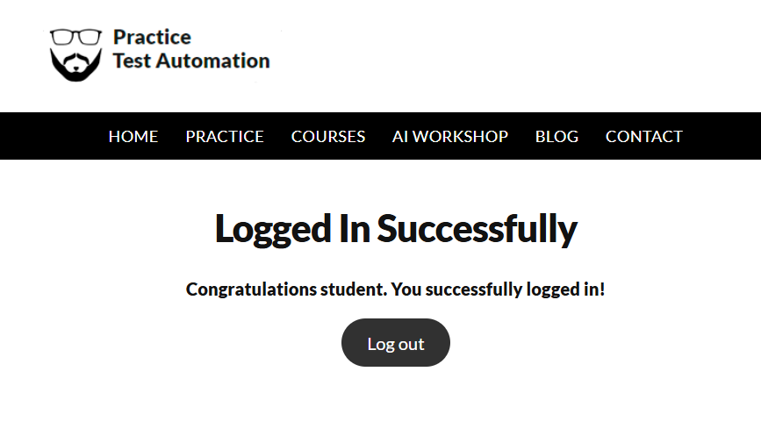

TC_AUTO_002 | Verify login fails with invalid username and valid password | Pass
Steps: 1. Navigate to login page | 2. Enter Username = incorrectUser | 3. Enter Password = Password123 | 4. Click Submit
Test Data: incorrectUser / Password123
Expected: Error banner displayed with text 'Your username is invalid!'
Actual: Error banner displayed: 'Your username is invalid!'
TC_AUTO_003 | Verify login fails with valid username and invalid password | Pass
Steps: 1. Navigate to login page | 2. Enter Username = student | 3. Enter Password = incorrectPassword | 4. Click Submit  Test Data: student / incorrectPassword  Expected: Error banner displayed with text 'Your password is invalid!'  Actual: Error banner displayed: 'Your password is invalid!' |  | 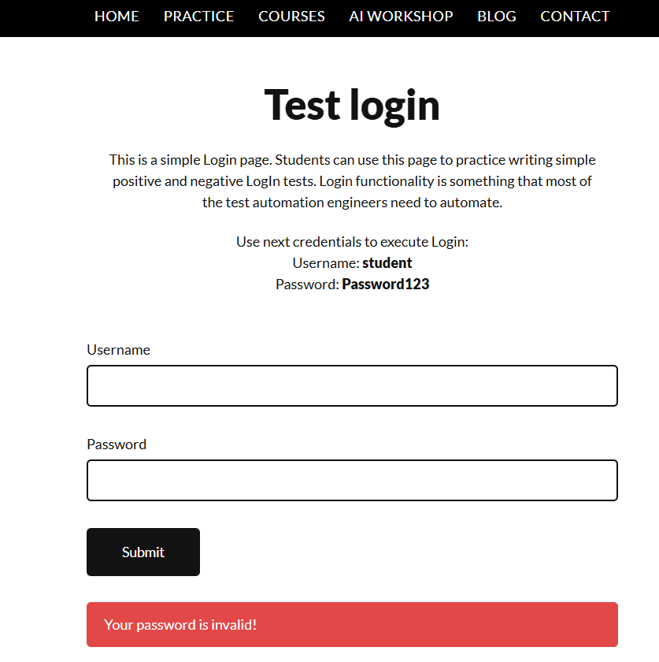

TC_AUTO_004 | Verify login fails with invalid username and invalid password | Pass
Steps: 1. Navigate to login page | 2. Enter Username = wrongUser | 3. Enter Password = wrongPass | 4. Click Submit  Test Data: wrongUser / wrongPass  Expected: Error banner displayed with text 'Your username is invalid!' (username validated before password)  Actual: Error banner displayed: 'Your username is invalid!'; confirms validation order checks username field first |  | 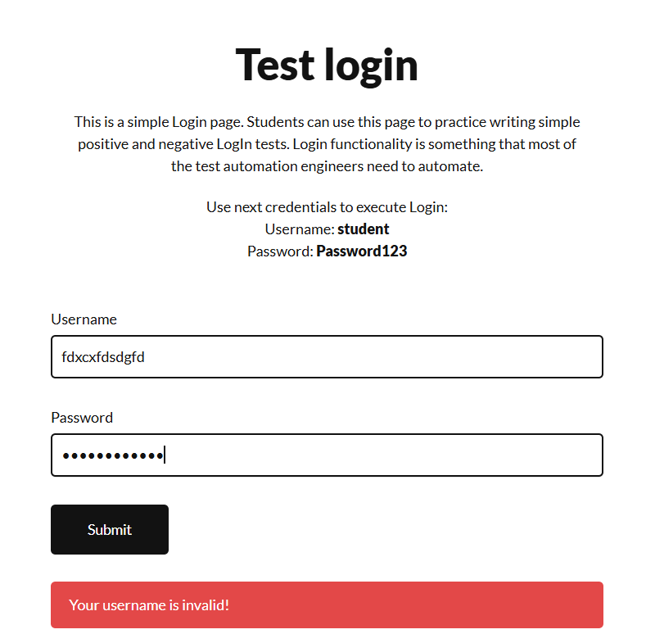

TC_AUTO_005 | Verify login fails when Username field is left empty | Pass
Steps: 1. Navigate to login page | 2. Leave Username blank | 3. Enter Password = Password123 | 4. Click Submit  Test Data: '' / Password123  Expected: Error banner displayed with text 'Your username is invalid!'  Actual: Error banner displayed: 'Your username is invalid!'; empty string treated same as any non-matching value |  | 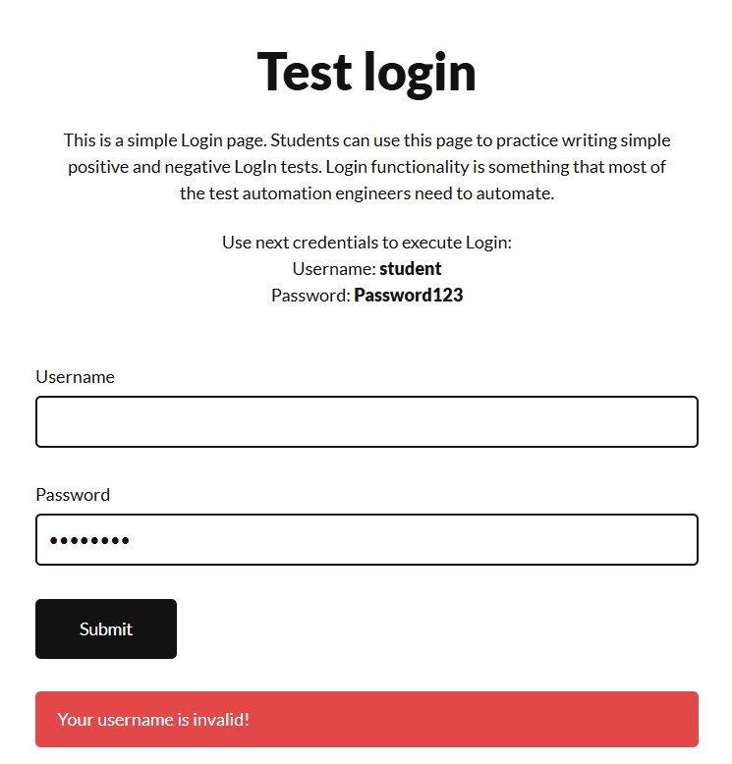

TC_AUTO_006 | Verify login fails when Password field is left empty | Pass
Steps: 1. Navigate to login page | 2. Enter Username = student | 3. Leave Password blank | 4. Click Submit
Test Data: student / ''
Expected: Error banner displayed with text 'Your password is invalid!'
Actual: Error banner displayed: 'Your password is invalid!'

